**Changing Idea Entity Email Password for the First Time**

1. Please login to the webmail using the below URL.

<https://mail.ideaentity.com/owa>

1. Enter the provided **Domain\user name** and **Password** in the email and click Sign in.

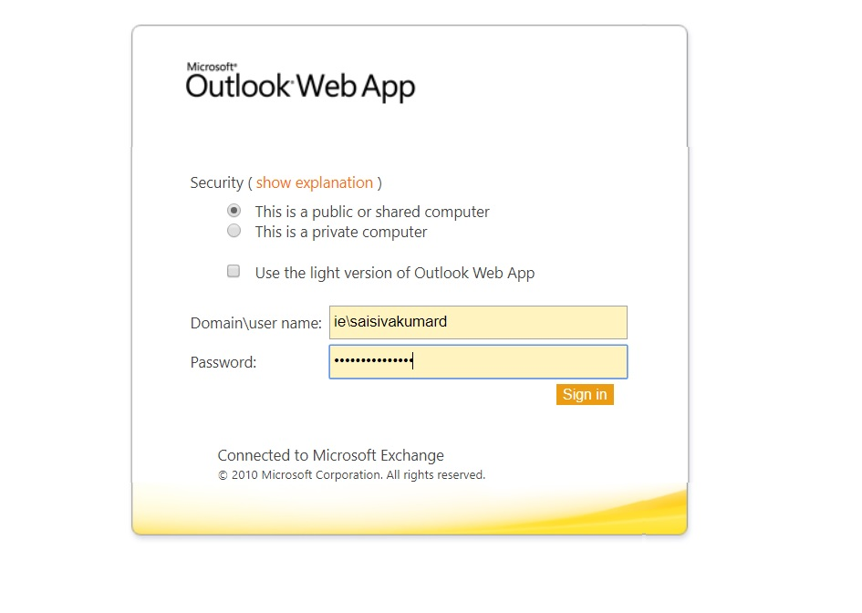

1. Now in the next page it will ask the user the change the old password.

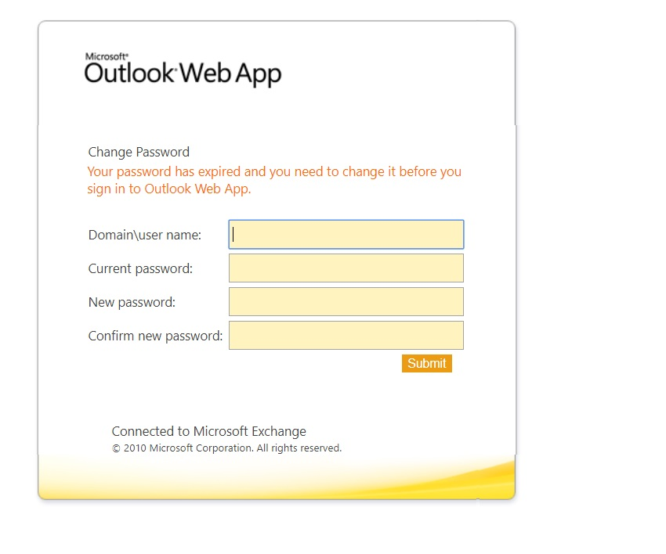

1. Enter **Domain\user name and current password** as provided in the email and New password.

**Note:**

New password requirements -- Be at least 8 characters in length, contain at least 1 lowercase and 1 uppercase letter, contain at least 1 special character, contain at least 1 number